Data Flow Diagram & User Stories
Date | 28 Sept 2026
Team ID | __________
Project Name | LegalEase – AI-Powered Legal Document Generator
Maximum Marks | 4 Marks
The following is prepared in the same format as your template, using the LegalEase project specification. The specification describes a user entering document type, parties, terms and effective date; the request goes through the application/backend to Gemini; the generated document is previewed, edited and exported.

1. Data Flow Diagram (DFD)
Level-0 DFD / Context Diagram
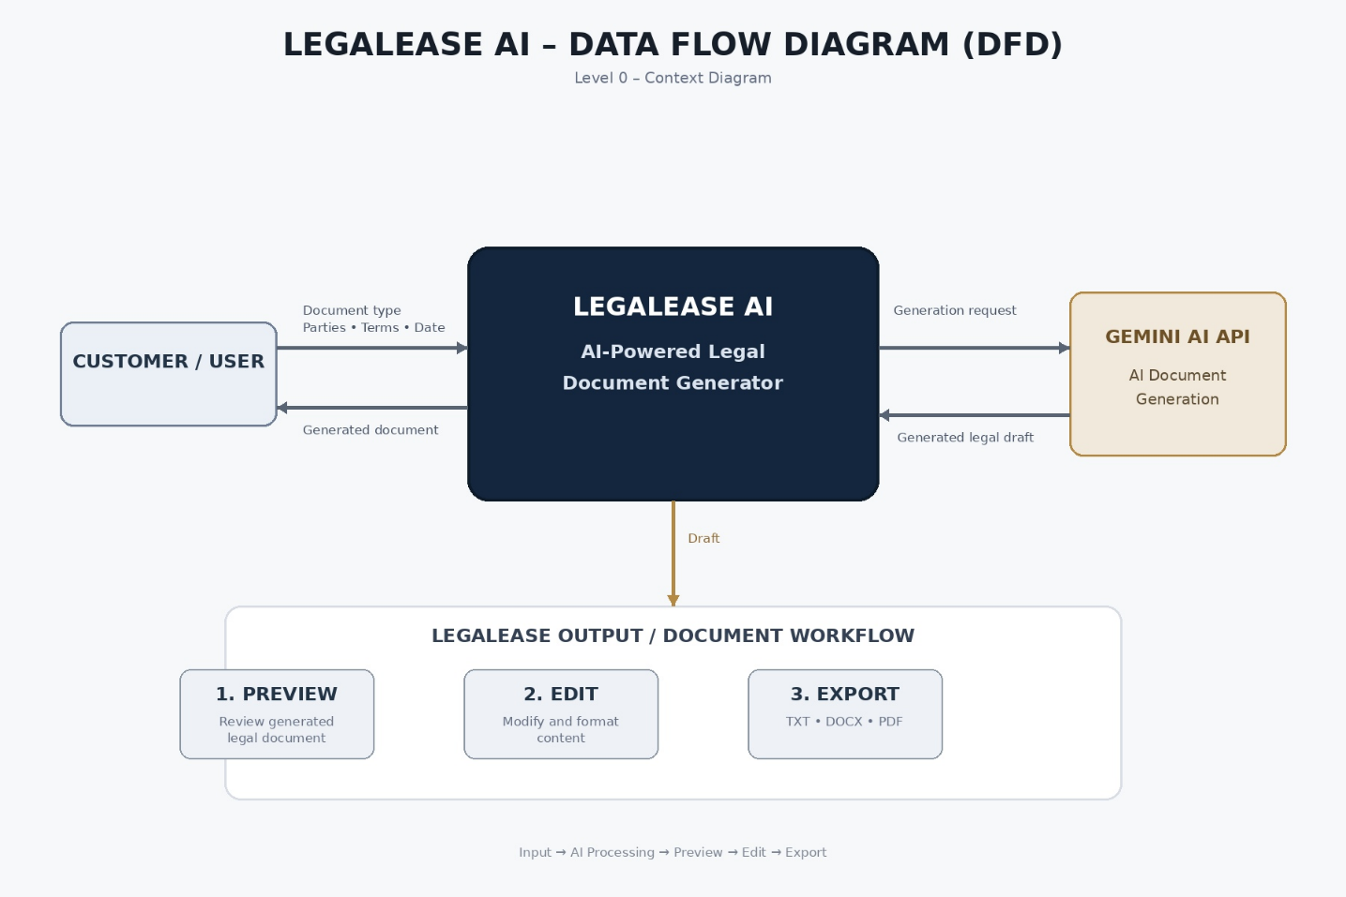
Main Data Flows
Source | Data | Process | Output
Customer/User | Document type | Document generation | AI-generated draft
Customer/User | Parties involved | Document generation | Customized content
Customer/User | Terms & conditions | AI processing | Legal clauses
Customer/User | Effective date | Document generation | Complete document
Gemini AI | Generated content | Preview & editing | Editable document
User | Edited content | Formatting/export | Final document
LegalEase | Final content | Export | TXT / DOCX / PDF
The project specification identifies Gemini API, FastAPI, document generation, preview/editing and TXT/DOCX/PDF export as the main workflow components.
2. DFD – Level 1
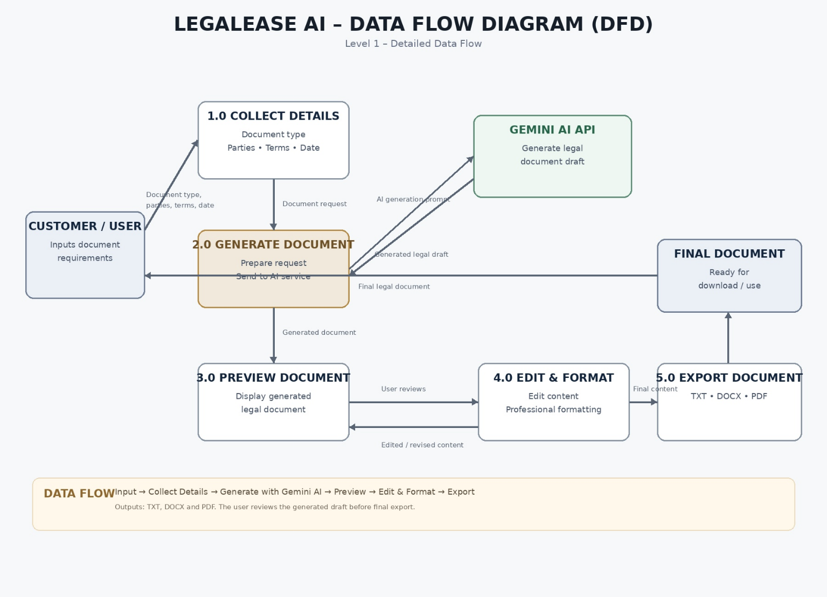
3. User Stories
User Story Table – LegalEase AI
User Type | Functional Requirement (Epic) | User Story Number | User Story / Task | Acceptance Criteria | Priority | Release
Customer / Web User | Document Generation | USN-1 | As a user, I can select the type of legal document I want to create. | I can select a document type such as Employment Contract, NDA, Lease Agreement or Service Agreement. | High | Sprint-1
Customer / Web User | Document Generation | USN-2 | As a user, I can enter the parties involved in the document. | I can enter the names/roles of the parties involved. | High | Sprint-1
Customer / Web User | Document Generation | USN-3 | As a user, I can enter the terms and conditions required for my document. | I can enter multiple terms and conditions in the input form. | High | Sprint-1
Customer / Web User | Document Generation | USN-4 | As a user, I can select the effective date of the document. | The selected effective date is included in the generated document. | High | Sprint-1
Customer / Web User | AI Generation | USN-5 | As a user, I can generate a customized legal document using AI. | The system generates a document based on my document type, parties, terms and effective date. | High | Sprint-1
Customer / Web User | Document Preview | USN-6 | As a user, I can preview the generated legal document before downloading it. | The generated document is displayed in a readable preview. | High | Sprint-1
Customer / Web User | Document Editing | USN-7 | As a user, I can edit the generated document before exporting it. | I can modify the generated content and save the changes. | High | Sprint-1
Customer / Web User | Document Formatting | USN-8 | As a user, I can view the document with professional formatting. | The document contains structured headings, clauses and readable formatting. | Medium | Sprint-2
Customer / Web User | TXT Export | USN-9 | As a user, I can download the generated document as a TXT file. | A TXT file containing the final document is downloaded successfully. | Medium | Sprint-2
Customer / Web User | DOCX Export | USN-10 | As a user, I can download the generated document as a DOCX file. | A DOCX file containing the final document is generated successfully. | High | Sprint-2
Customer / Web User | PDF Export | USN-11 | As a user, I can download or save the generated document as a PDF. | The final document can be printed/saved as PDF. | High | Sprint-2
Customer / Web User | Branding | USN-12 | As a user, I can receive a professionally formatted document with branding elements. | The document can contain logo, header and footer formatting. | Medium | Sprint-2
Customer / Web User | Document Types | USN-13 | As a user, I can create different types of legal documents using the same application. | The application supports the specified legal document categories. | High | Sprint-1
Customer / Web User | Validation | USN-14 | As a user, I should be informed when required document information is missing. | The system prevents generation until required fields are completed. | High | Sprint-1
Customer / Web User | Legal Review | USN-15 | As a user, I can review the generated document before using it. | I can inspect and edit the generated draft before export. | High | Sprint-1
The document types listed above are based on the project specification, which includes employment contracts, NDAs, lease agreements, service agreements, freelance contracts and employment offer letters.

4. User Stories – Scenarios
You can also include the three major scenarios from the project:
User Type | Functional Requirement (Epic) | User Story Number | User Story / Task | Acceptance Criteria | Priority | Release
Startup Founder | Employment Contract | USN-16 | As a startup founder, I can generate an employment contract for a new employee. | The system generates an employment contract using the employee/employer details and required terms. | High | Sprint-1
Freelancer | NDA Generation | USN-17 | As a freelancer, I can generate an NDA for a potential client. | The system generates an NDA containing the provided parties and confidentiality terms. | High | Sprint-1
Landlord | Lease Agreement | USN-18 | As a landlord, I can generate a residential lease agreement. | The system generates a lease agreement using the provided parties, terms and effective date. | High | Sprint-1
Customer / Web User | Preview & Editing | USN-19 | As a user, I can review and modify the generated document before downloading it. | The generated document can be previewed and edited. | High | Sprint-1
Customer / Web User | Export | USN-20 | As a user, I can export my final document in a suitable format. | TXT, DOCX and PDF export options are available according to the implemented release. | High | Sprint-2

Suggested Epics for your project
